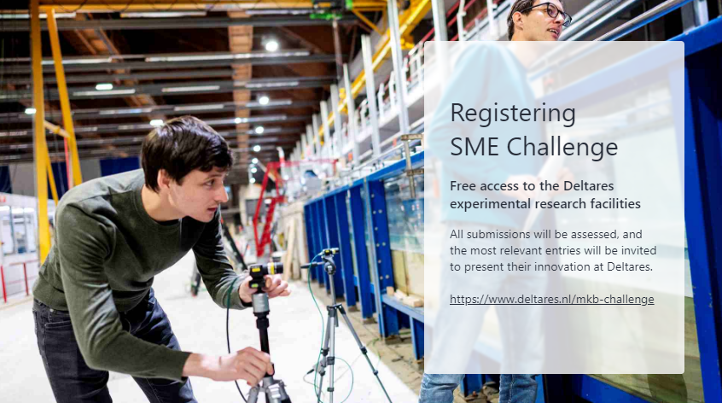

- Organisation:
- Website:
- Contact person(s):
- Email address(es)::
- Name of your innovation/concept
and brief description):
- Explain the innovation or concept your SME/start-up offers. Describe how your innovation addresses specific challenges and what makes it unique:
- Describe your business.
The description should include at least the following:
  - Background information about the company/organisation.
  - Corporate/organisational goals/ambitions.
  - Relationship with Deltares (previous contact and/or cooperation) and societal challenges (what problem/ambition are you addressing?).
  - Market opportunities (who are your target end-users, what is the market potential (NL / INTL)?)
- Describe the testing approach and purpose.

The description should include at least the following:
- Test purpose(s) (i.e. testing the stability of an armoured rock layer).
- Test approach (i.e. testing a 1:20 breakwater in the Scheldt channel with varying hydraulic conditions).
- Estimated number of days needed for construction, testing and dismantling.

- Describe your sources. The description should include at least the following
  - Resources provided by your organisation* (e.g. model parts, availability).
  - Resources you need from Deltares (e.g. advice on setting up a testing programme).

*Note: Deltares' role is mainly supportive, so only advice in preparation and support during construction, testing and dismantling.
- Provide brief background information relevant to your innovation/concept (e.g. recent graduates):
- What is the desired facility, out of our full range of facilities, that you would like to use?

More information can be found at: https://www.deltares.nl/en/research-facilities

- By what date could your model/concept be ready to be tested at Deltares?
- Do you have files that help visualise your innovation/concept, such as drawings, concept art, photos, videos, logos, and so on? | Paste them as attachments on the last page(s) in this document
- Conditions of application: | q YES, I agree and comply with all terms and conditions as stated in the MKB brochure and the MKB draft cooperation agreement, which can be found on the website page www.deltares.nl/en/about-us/alliances/sme/free-access-to-the-deltares-experimental-research-facilities-for-smes-and-start-ups

Annexes

Files that help visualise your innovation/concept, such as drawings, concept art, photos, videos, logos, and so on, paste onto this and any subsequent pages in this document (be careful not to make this file too large).

